Created - Train And Test Folders

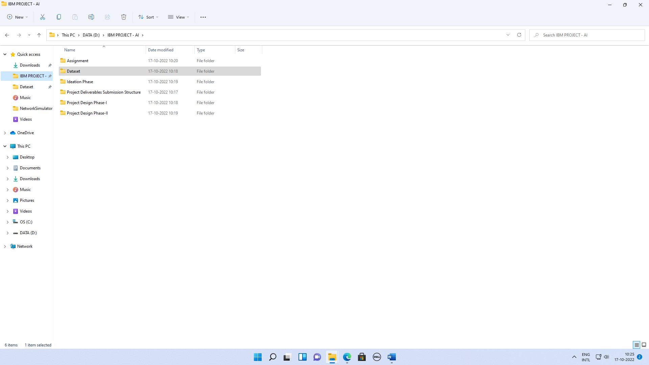**Team ID:** PNT2022TMID31248 **Project Name:** Real time communication system powered by AI for specially abled Stage 1: D:\IBM PROJECT – AI

